Document revision
Version | What changed | Date
0.1 | Initial upload | 02.04.2024
0.2 | Added new features, restructured the text a bit | 13.09.2024

Mission editor: triggers and conditions

The purpose of the document
This guide is to familiarize users with the usage of triggers/conditions to create event-rich missions in the mission editor.

The terms and concepts
Triggers
During gameplay the game constantly checks whether some Conditions are met and if these are, it performs some Actions that are “packed in” to a container named Trigger. This can vary from displaying a message to a player, achieving victory for a side of an engagement to adding/destroying units or changing their allegiance. Look at Triggers as at events that can occur during gameplay in some specific mission.
Actions
When Trigger’s Conditions are met then set of an actions can be performed by the game as follows:
- Display message to any/both of opposing sides
- End a mission with a victory for any of opposing sides
- Swap selected units to another side/taksforce changing their allegiance
- Teleport selected units to some position
Trigger’s Units
User can assign any units added to mission in a list associated with Trigger to affect these units by Actions
Conditions
Conditions are rules that determine whether a Trigger they associated with can be fired in some or other circumstances that can occur in a mission during gameplay. There are numerous rules and settings that can constitute Conditions and these will be described in detail below.
Conditions Complete Rule
This is a logical “formula” that determines relations between different conditions of a given Trigger. It is written in the plain text form. The syntax will be described below.

Preconditions
To make it worth to define any Triggers, it’s obligatory to add at least one group of units for both Red and Blue side in the Mission Editor first.

Example of units group setup
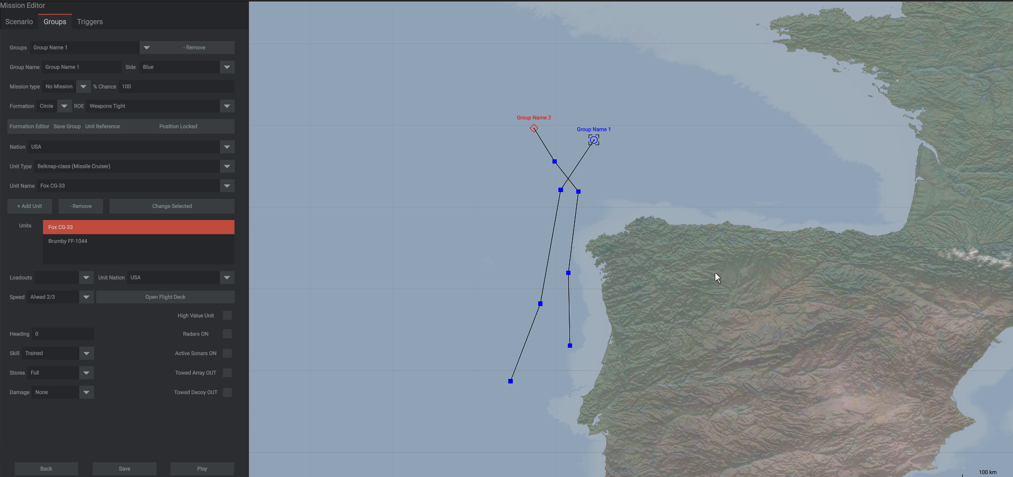

Create Trigger
- Open the Triggers Tab
- Click on the Add Trigger button
The following UI appears as a result:
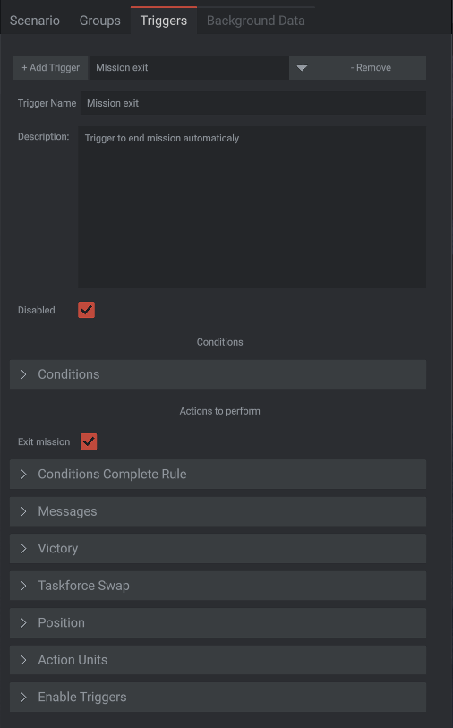
Trigger Name and Trigger Description fields are purely descriptive ones and not used during gameplay. Additionaly. Trigger Name is used to identify a trigger in mission file, so please ensuree that your Trigger Names are unique!
Disable checkbox: when ticked, it means that this Trigger is disabled and the game doesn’t check it when mission runs. But disabled trigger can be enabled by other triggers. Typically, you may want to have disabled Mission exit trigger that will be activated by Victory or Defeat trigger and ends the mission after x seconds.

Further below are:
The Consitions area:
Contains one collapsible block with the same name, this is where Conditions can be managed.

Actions to perform area:
Exit mission checkbox: when ticked, that means that this Trigger will force the mission to end when fired.
The area also contains collapsible blocks:
- Conditions: this is where Conditions can be managed
- Messages: what messages will be displayed when the Trigger is fired up
- Victory: the Trigger can be defined as victory conditions trigger here
- Taskforce Swap: units that will swap their taskforce (side) allegiance when the Trigger is fired up are listed here
- Position: Trigger position can be added here
- Action Units: units that will adhere to the selected actions when the Trigger is fired up
- Enable Triggers: here can be specified a list of Triggers that will be enabled if the current Trigger is activated

Add Conditions for the Trigger
- Open the Conditions collapsible block by clicking on its header
- Click on the Add Condition button
The following UI will appear as a result. It will display data for currently selected Condition
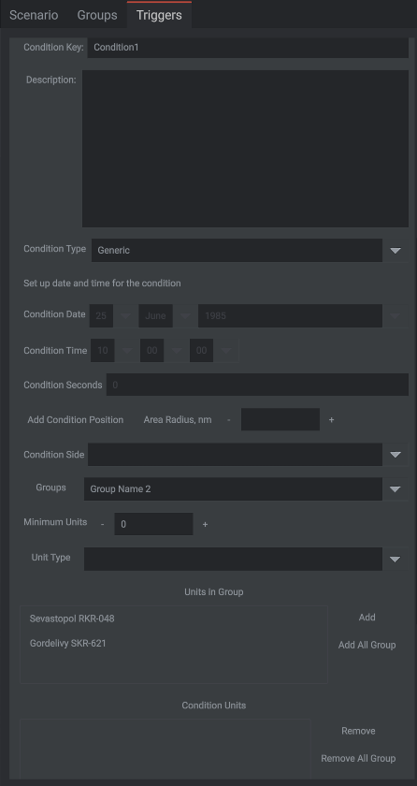
It contains the following UI elements:
- Condition Key: this should be a unique identifier to be used in Conditions Complete “formula”. It’s filled with default value like “ConditionN” where N is numeric that increments from 1 when a user adds new Condition, but a user can change it to whatever needed. The Condition Key uniqueness is necessary in scope of the same Trigger only.
- Description: purely descriptive field not used in gameplay
- Condition Type: this dropdown list provides an ability to select a type of the current Condition. The valid types currently are: Generic, Time, Unit destroyed, Unit enters area, No units of given type left
- Set up date and time for condition: if this checkbox is ticked then current Condition will be tied up to date/time selected below
- Condition date and time: UI elements that provide an ability to set up Condition Date and Time
- Condition Seconds: number of seconds from beginning of the Mission that corresponds to both specified Mission Start Date/Time and Condition Date/Time. It changes dynamically when any or both date/time values are changed. A user also can change this value directly and it will dynamically change the Condition Date/Time above
- Add Condition Position: when this button clicked, Condition Position can be added on the map. The cursor changes to cross. Left-click on any place on the map to add Condition position there. A Condition can contain only one position. Condition Position marker can be be moved along the map by drag-n-drop.
- Area Radius NM: this text input field is used to define Condition Position area Radius. The default value is 10 nautical miles. It can be changed directly in this field or by clicking on plus/minus buttons located before and next to the input field. The Condition Position Area is displayed on the map as a pink circle and changes dynamically when Area radius value changed.
- Condition Side: to select a side to apply the Condition to, can be Blue, Red or Neutral
- Groups: this is a dropdown list of all groups currently listed in the mission, when some Group is selected on it, the Units in Group listbox below is refreshed with the currently selected Group unit composition
- Minimum Units: minimal number of units that should apply to the Condition, e.g. how much of the listed units should be destroyed, as an example
- Units in Group: as already stated above, the list of units that combine currently selected Group. To the right-hand side of this list the Add and Add All Group buttons located. Add adds currently selected unit to the Condition Units list, Add All Group adds the whole currently selected group
- Condition Units: this listbox contains list of units that associated with the current Condition. A user can selected any unit in the listbox and click on the Remove button to delete this unit from the list or click on the Remove All Group button to delete the whole Group the selected unit belongs to
You can add several conditions to the current Trigger of different types, there is no any limitation on number of Conditions per Trigger.

Conditions Complete Rule
This collapsible block contains a plain text box that provides an ability to specify Conditions that belong to the current Trigger will be used and logical relationships between them.
The syntax used is:
Triangle brackets < and > are used to denote the Condition Key, so any Condition Key between these brackets will be perceived by the game code as a condition identifier.
Example: <Condition1>
Round brackets ( and ) is used to denote some level or group of an expression as used in math.
Example: (Condition1 AND Condition2) AND Condition3
Reserved words used to create logical relationships:
AND: if conditions or groups to left and to right of this word are met, the whole expression is met
OR: if any of conditions or groups to right or to left of this word is met, the whole expression is met
NOT: this word reverses the logical condition
The AND, OR and NOT should be written using uppercase.
Examples:
<Condition1> AND <Condition2>
If both Condition1 and Condition2 are met, the expression is met and the Trigger fires up.
<Condition1> OR <Condition2>
If either Condition1 or Condition2 is met, the expression is met and the Trigger fires up.
<Condition1> AND NOT <Condition2>
This expression fires when and only when Condition1 is met but Condition2 is not met. If Condition2 is met then the Trigger cannot be fired up.
Complex expression
(Condition1 OR Condition2) AND Condition3 OR Condition4
The expression above will be fire up the Trigger in this situation: Condition1 or Condition2 met and Condition3 is also met in the same time. But if Condition4 is met, it’s alone enough to fire up the Trigger.

Messages
This expandable block contains two plain text texboxes with message texts for Blue and Red sides respectively. In case the player side changes in the mission the appropriate message text will be used in game. A user can utilize standard xml formatting tags in this box.
Message example with formatting and styling tags
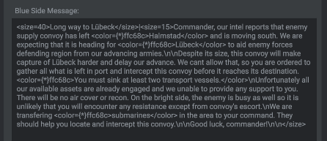

Besides the standard tags some custom tags can be added to the text to display some in-game values that should be specified in curvy brackets and starts with $ character, such as:
{$TrackId} – track id of affected unit is displayed
{$UnitClass} – unit class name is displayed such as “Iowa BB”
{$UnitClassFull} – full class name such as “Iowa class BB”
{$UnitName} – unit name such as “Sovremenny”
{$UnitNameFull} — full unit name such as “Sovremenny class DDG”
All unit class/names values will be extracted by the game from current language files.

Victory
This expendable block contains means to designate current Trigger as a Victory Trigger for any Blue or Red sides. The UI elements within the block are:

Victory Trigger checkbox. When it ticked, the current Trigger becomes the Victory Trigger and will define victory or defeat for any of sides.

Victory Trigger: if this checkbox is ticked current Trigger becomes victory trigger
For Side: the dropdown list to select a Side to award a victory to
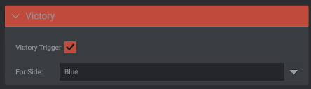

Taskforce Swap
Here a user can select a Side to convert Trigger Units to from their current allegiance. Contains just one Swap Units to Taskforce dropdown

Position
This expandable block contains UI elements to define Trigger Position on the map.
Add Trigger Position: when this button clicked, Trigger Position can be added on the map. The cursor changes to cross. Left-click on any place on the map to add Trigger position there. A Trigger can contain only one position. Trigger Position marker can be be moved along the map by drag-n-drop.
Area Radius NM: this text input field is used to define Trigger Position area Radius. The default value is 10 nautical miles. It can be changed directly in this field or by clicking on plus/minus buttons located before and next to the input field. The Trigger Position Area is displayed on the map as a pink circle and changes dynamically when Area radius value changed.
Teleport To Position: if this checkbox is ticked, the Action Units teleport to the position specified when the Trigger fires up.
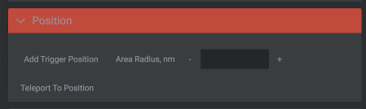

Action Units
Groups: this is a dropdown list of all groups currently listed in the mission, when some Group is selected on it, the Units in Group listbox below is refreshed with the currently selected Group unit composition.
Units in Group: as already stated above, the list of units that combine currently selected Group. To the right-hand side of this list the Add and Add All Group buttons located. Add adds currently selected unit to the Action Units list, Add All Group adds the whole currently selected group.
Action Units: this listbox contains list of units that associated with the current Trigger. A user can selected any unit in the listbox and click on the Remove button to delete this unit from the list or click on the Remove All Group button to delete the whole Group the selected unit belongs to.

Enable Triggers
Here a user can define the list of Triggers that can be enabled when the current trigger fired.
Triggers: this combobox displays the current list of all Triggers available.
Triggers to enable: this listbox contains Triggers that were selected in the Triggers combobox and added to the list by clicking on the Add button right to the listbox.
Remove button just removes a Trigger selected on the listbox from it.

